Evaluation of the “Tempus HESDESPI” project

Report of evaluation in the middle of the project

Stockholm 2011-12-01

Hans Skoglund

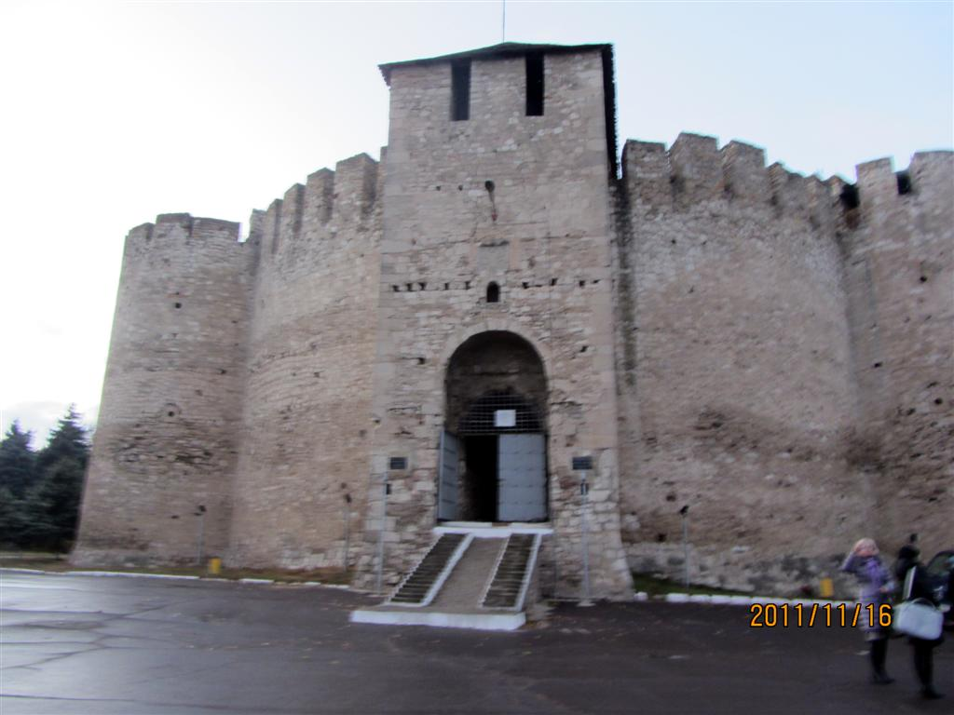
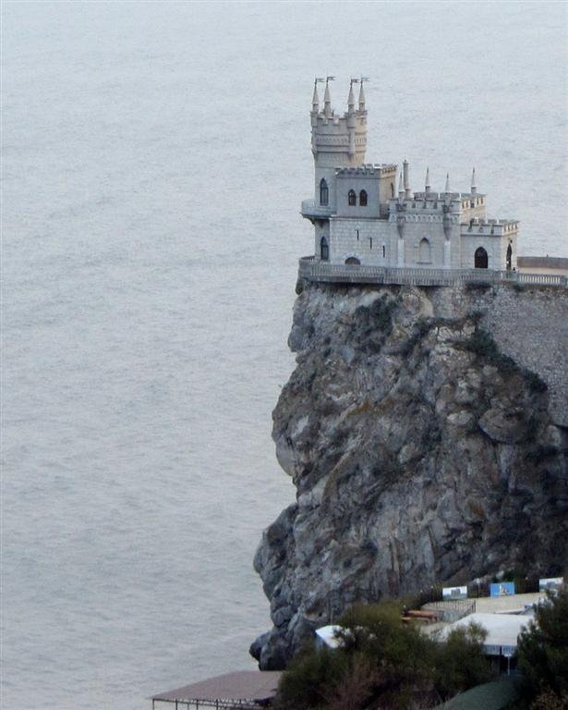
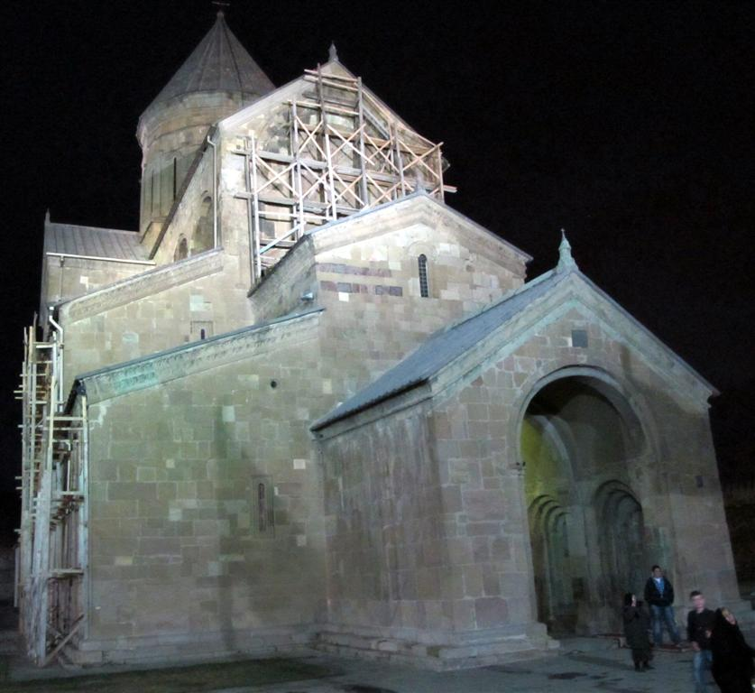
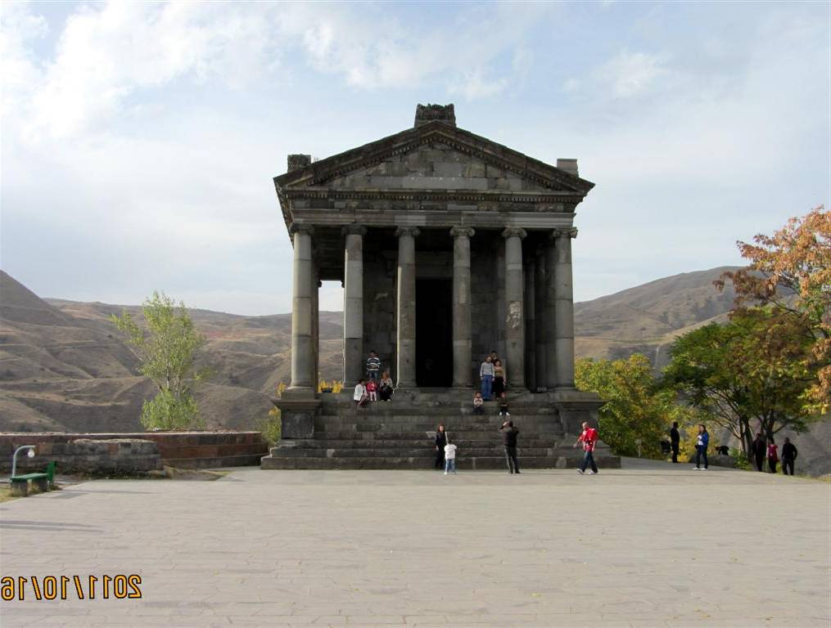
Some landmarks from the four participating countries

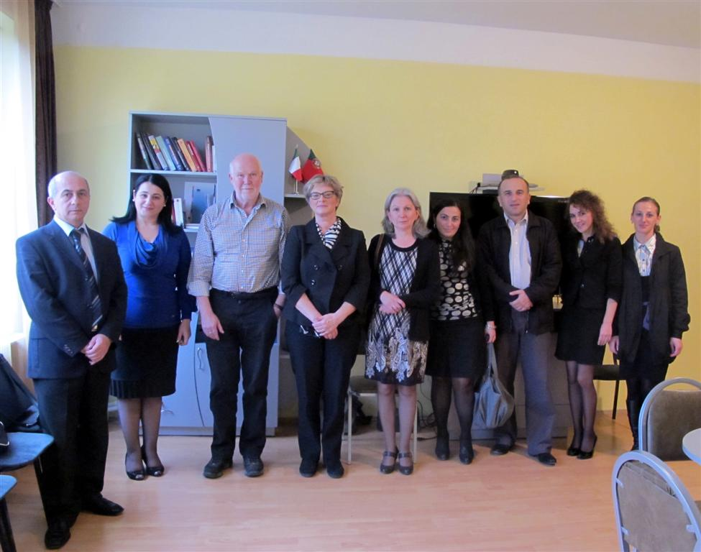
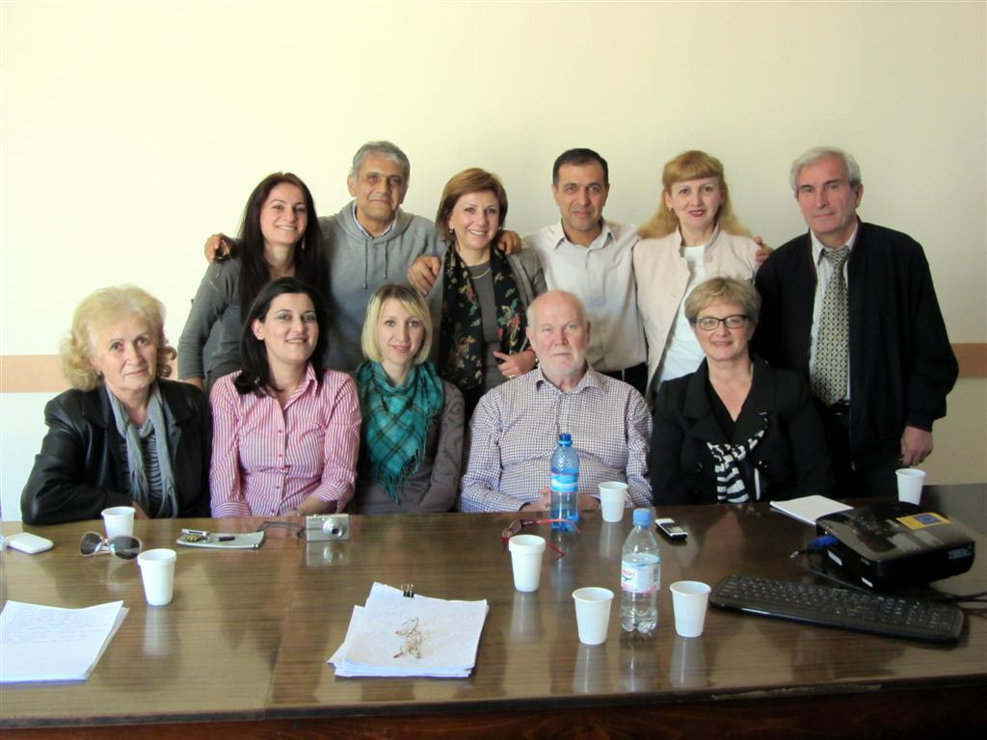
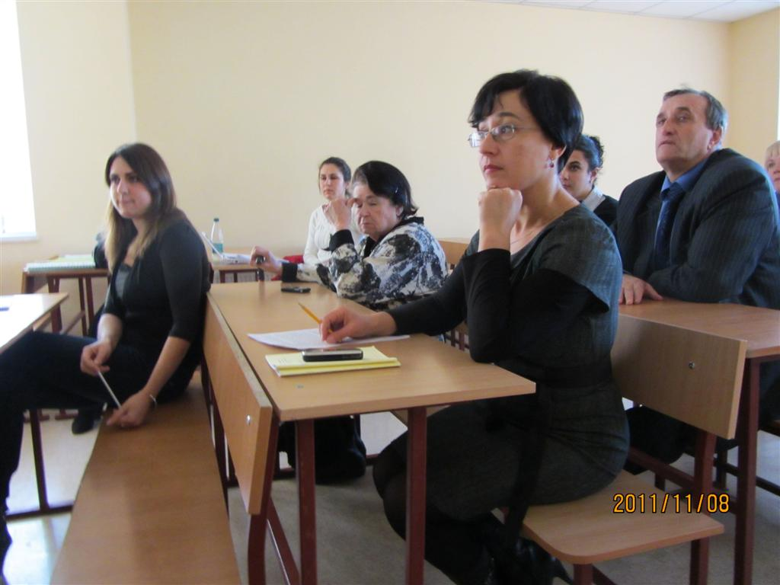
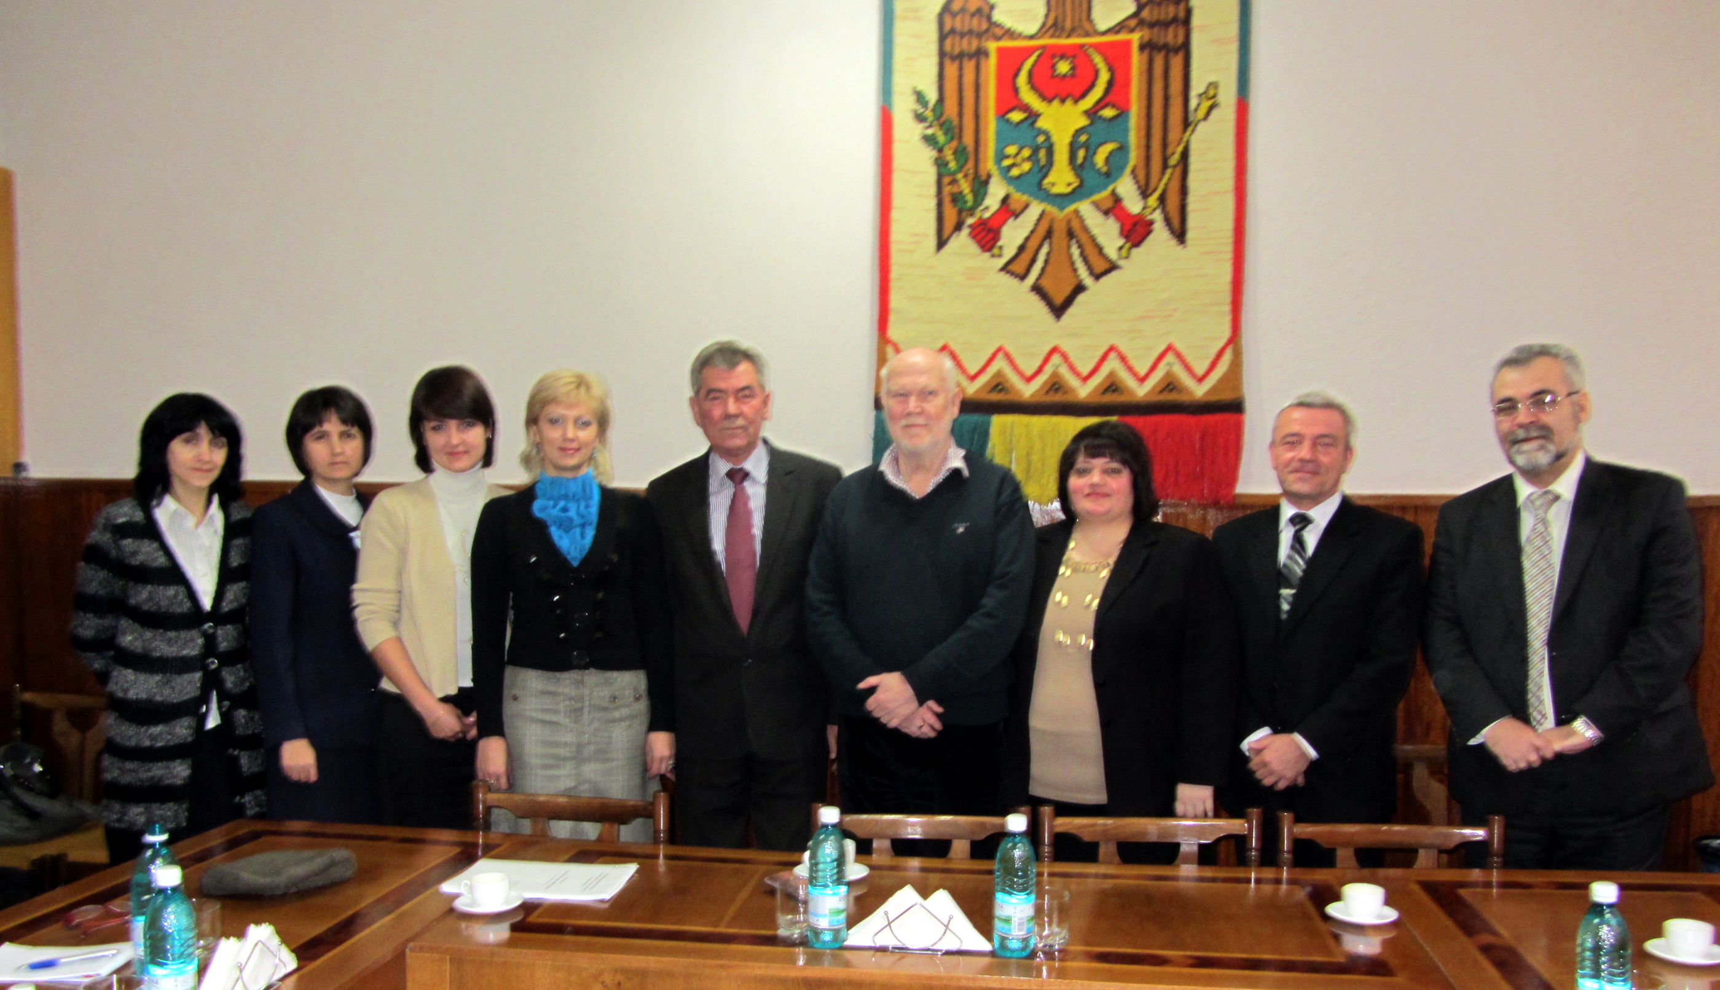
Places I visited during the evaluation
Meeting in Tbilisi
Meeting in Yerevan
Meeting in Simferopol
Meeting in Balti

Content

Page

Hans Skoglund’s report 4

Annex 1 Armenia 14

Annex 2 Georgia 22

Annex 3 Moldova 29

Annex 4 Ukraine 35

Tempus programme project HESDESPI

Performed by Hans Skoglund

Stockholm, Sweden 2011-11-29

Visits
In order to make a research of how the HESDESPI project is going on I made the following visits to the project

13 – 14 October Sokhumi State University Tbilisi, Georgia

15 – 17 October Yerevan Fine Arts Academy and Yerevan State University of Architecture, Yerevan, Armenia

7 – 10 November Taurida National V.I. Vernadsky University, Simferopol, Ukraine

14 – 17 November Cahul State University and Balti State University, Moldova
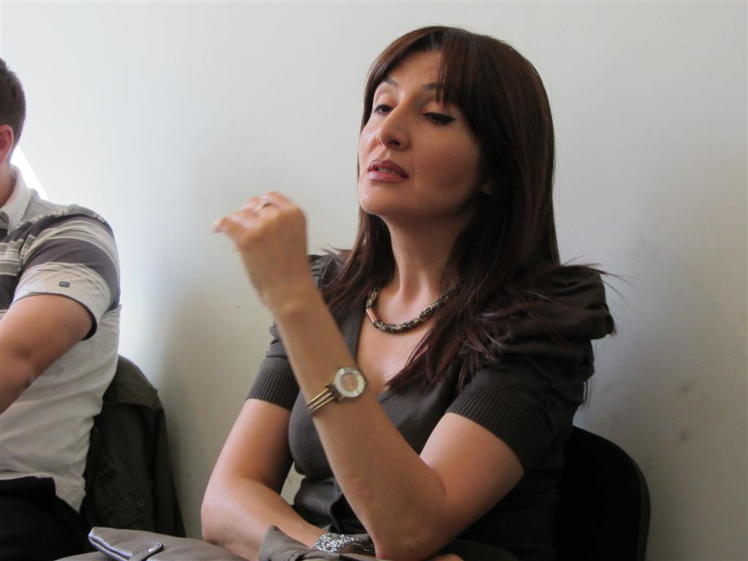
Meetings

Armenia
Meeting with the leaders of the project, teachers, rectors and vice rectors of the University and Academy, members of the advisory board and representative from Department of Culture and Arts and Department of education and Science.
Representative from Department of Culture and Arts

I also visited several museums that also are members of the advisory board.
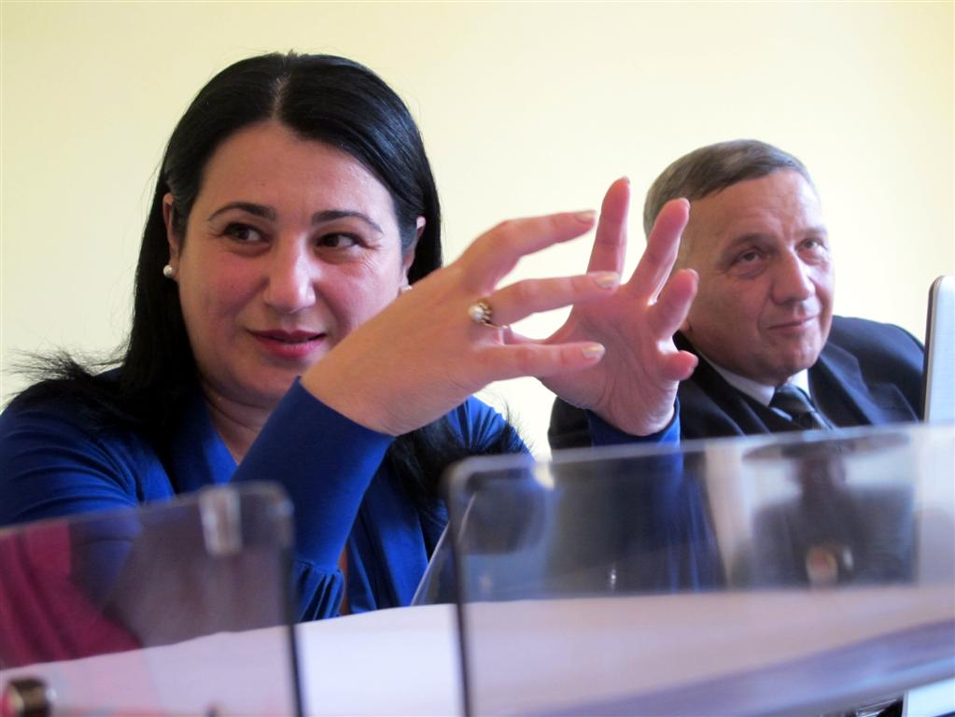
Georgia
Meeting in Sokhumi State University with leaders of the project, headmaster, representatives from Department of Culture and Arts and Department of Education and Science, teachers and six students.
Indira Dzagania

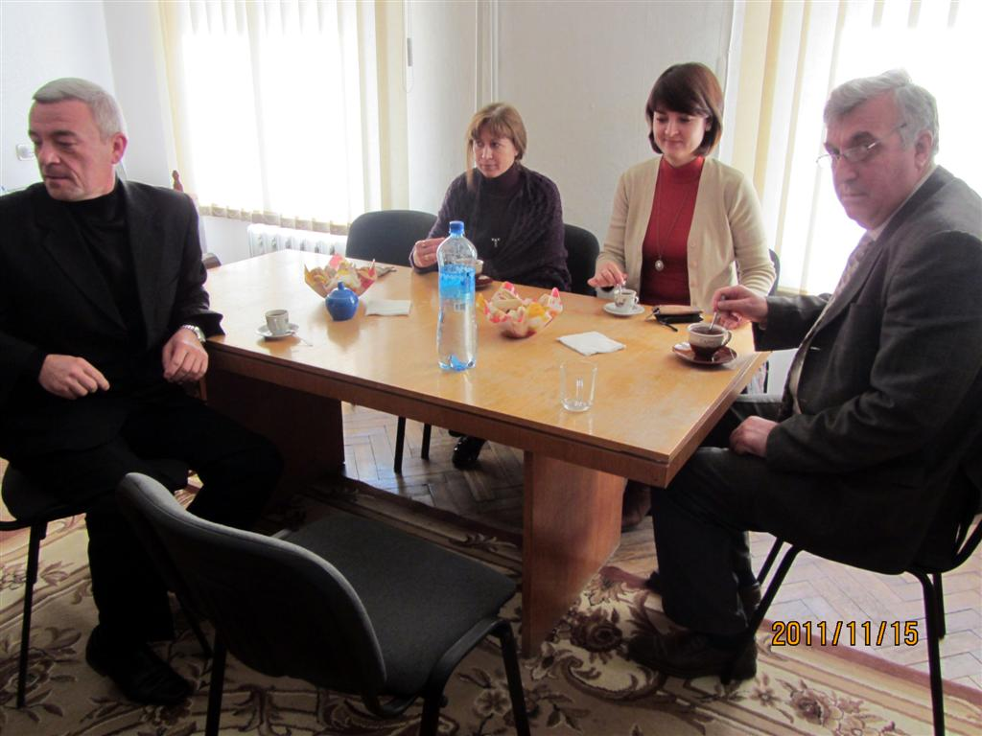
Moldova
Meetings in Cahul with leaders of the project nationally and locally.
Meeting in Balti with leaders of the project nationally and locally. I also met and discussed with headmaster and vice headmaster. Balti University also arranged a seminar where they presented the involvements in five EU-projects including HESDESPI for staff in the University.
In Cahul

Ukraine
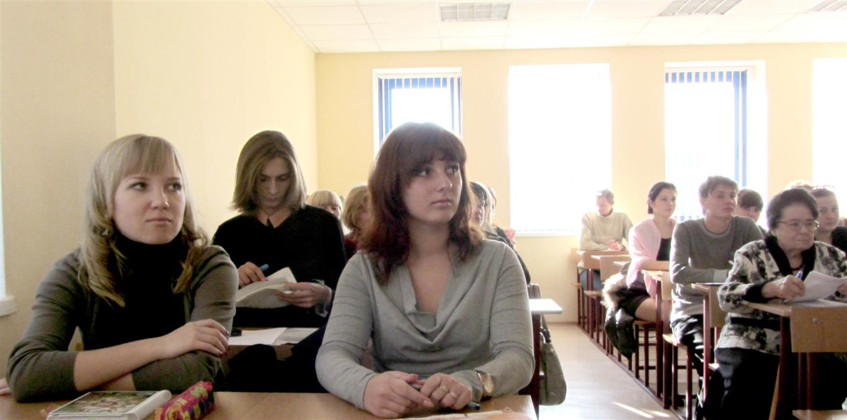
Meetings in Simferopol with leaders of the project nationally and locally. I had discussion with staff and leader of department and also met and discussed with ca 25 students and teachers.

In all countries they gave me interesting sightseeing and explained a little of the “soul” in their country. It is important for a foreigner to realize and understand the environment and the values that builds a project.
Discussion with students in Simferopol

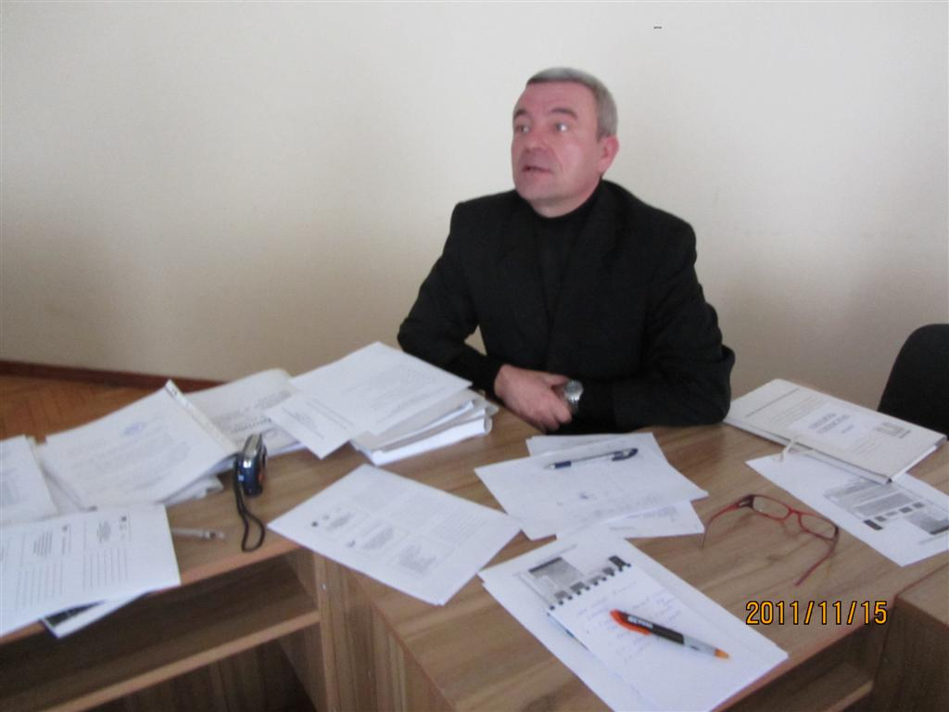
Papers of the project
It has been a lot of papers written in this project. I have collected some of them and put them as annexes to this report. For details I recommend to read them.

Those papers are an answer to the questions given by ISMA and give more concrete answers for every country.

I will here make conclusions on different questions and also deepen some topics.
Lot of papers – not only in Moldova

Conclusions of answers at ISMA´s questions

General comments
After my tour I am impressed of the work done in the project. You may think that three years is a long time. But it takes time to make studies over labour market, find new co-operations with new partners, making all the plans and modules, start a network, persuade colleagues and implement the ideas to staff and students in your own University. To my opinion all the partners has succeeded in this. They are very engaged and professional to develop the project according to goals.

They have created a new spirit and view in society’s that still carries a heavy Soviet Union rug sac with reminiscence of old thinking and old solutions. They have taken important steps that hopefully will influence the coming education in Universities and this will contribute to more open minded, listening and democratic universities in the future.

I got information about difficulties, when partners wanted to change curricula that needed to be decided on national level. That can take years, if ever. That situation can maybe not be solved in a project like this, but will hopefully be solved in the future.

Quality of the study programmes concept in related study courses (Humanity sciences, Culture administration)
The Universities has chosen subjects after their normal subjects, which was discussed in Riga. In Moldova for instance they have teacher and linguistic courses. That’s why they work from this point of view. I see that as a practical solution to be able to participate. In Armenia they meant that it was more necessary to work with Arts management, which was underlined from the representative from the Culture department. Ukraine and Georgia has Culture Management. As a whole the partners solved the task, but in different ways.

Presence of training materials for elaborated study courses (quality and languages available)
All partners have this. Some have written new books in the national language like Armenia and Moldova. Others has made choice of the best books in Russian, English and there own language. See more in the annexes.

Methodological recommendations for developing qualification exam/paper content
Methodological recommendations of EU Educational Institutions (Bologna University – Italy, Minho University – Portugal, ISMA – Latvia) are used by the staffs. See more in Annexes.

Process of approbation and testing of training modules
Processes are going on among all partners. See Annexes.

Links between the current study programme and other courses of study in the study related organisational unit.
Also in this field the partners have made a good work. For details see Annexes.

The compliance of study programmes with needs of labour market and future skills of graduates, the co-operation with labour market is justified (concluded contracts, agreements, meeting protocols etc.).
This is to my opinion one of the most important issues in the project. It has created a totally new and important connection for the universities. Through this network the universities can wider their connection into the society and get hints for their future development.

Those networks are not same in the different countries.

In Armenia participates Unions for cultural actors like Union of Architects of Armenia, the Designers Union, the Union of Builders, the Painters union, the sculptor unions, curators' association, Modern art museum and Tourism Association in an advisory boards. The project meets the board continuously. Different types of agreements and contracts are written.
In Georgia participates representatives for theatres, museums and touristic agencies. They have also connections to Culture Department that supports the project. The project meets continuously with above organizations. Different types of agreements and contracts are written

In Moldova participates Union’s organisation, secondary schools and regional department of education. Through the project a better co-operation has started within the regional departments.

In Ukraine Managers of museums, managers of tourist activity, methodologists-organizers, art critics, teachers-psychologists, research scientists, marketing experts, experts in management of collections, etc.

My comment
I realise that the choice of social partners is an answer to the goals in the project. It could be interesting to look at other groups as well. An idea might be how to connect to the students and involve them more in the development of Universities and thereby train democratic processes. It may also be important to reach people outside University with courses and lectures, and listen to there experiences in life and work. People outside universities can contribute to the development of the universities. There are methods to catch ideas from outside and use them I a renewing process.

The compliance of study programs structure and content with legal regulations in partner country.
All the partners mean that the structure and content of the study program fully complies with state legal regulations.

Quality of implementation of study programs- availability of human and technical resources.
The teachers are enough educated and the technical resources are also satisfying. Ever University has a Tempus room with all equipment. They also maintain the technique continuously.

Use of state-of-the art equipment for implementing of educational programs (e.g. computers, multimedia techniques, software).
Universities have enough state-of-the art equipment for the implementation of educational programs. Periodically universities buy necessary equipment (computers, multimedia techniques, software) for the organization of educational process. Besides, the universities participate in different international project very active that allows them to update equipment and train staff.

Existence of developed professional standard for each qualification.
All partners mean that they through the education in Bologna, Braga and Riga got input for a forth going development of professional standards.

Conformity of professional qualification for involvement in European Qualification Framework, development of documentation regarding ECTS and EQF
In this field it is problems. The authorities have got suggestions from the universities of Armenia and Moldova already a couple of years ago, but have so far not made any decisions. Hopefully they will make it soon. More information Annexes.

Level of development of methodological recommendations regarding improvement of higher education offer, content and educational and management processes
The cooperation with labour market has created a new thinking. The dialogue has led to better respect and understanding between the parts. Studies have been written and presented.

Publications in mass media and informative articles regarding the project and its outcomes
This has been done through the normal university channels, the website, seminars, TV and press. Some of the countries have also made books and exhibitions.

Summary of the answers

Questions | For all countries
Quality of the study programmes concept in related study courses (Humanity sciences, Culture administration); presence of elaborated 5 study modules and representation of necessary topics and skills in them. | Done
Presence of training materials for elaborated study courses (quality and languages available) and methodology of use of training methods, case studies and workshop examples | Done
Methodological recommendations for developing qualification exam/paper content | Done
Process of approbation and testing of training modules | Done
Links between the current study programme and other courses of study in the study related organisational unit | Done
The compliance of study programmes with needs of labour market and future skills of graduates, the co-operation with labour market is justified (concluded contracts, agreements, meeting protocols etc.) | Done and partly done
The compliance of study programmes structure and content with legal regulations in partner country | Done
Quality of implementation of study programmes- availability of human and technical resources | Done
Use of state-of-the art equipment for implementing of educational programmes (e.g. computers, multimedia techniques, software) | Done
Existence of developed professional standard for each qualification | Done and partly done
Conformity of professional qualification for involvement in European Qualification Framework, development of documentation regarding ECTS and EQF | Efforts made but in some of the countries the have not ended up in desitions.
Level of development of methodological reccomendations regarding improvement of higher education offer, content and educational and management processes | Done
Publications in mass media and informative articles regarding the project and its outcomes | Done

This means so far that all the partners have succeeded very well.

Learning evaluation
In learning evaluation, which has become popular in European projects, the evaluator is following the project from the first day and is interacting with the project through the project time. This was not the case in this project. As evaluator I had a lack of information from the start. I understood the project first after visiting most of the participants. The leader of the project has to think this over and use that in an eventual new project.

In the discussions I had with the participants we didn’t discuss how to evaluate the new courses with the students. It is important to create models for this work so you can compare the results between different countries and participants.

UNESCO has written materials about learning evaluation ( se http://unesdoc.unesco.org/images/0018/001871/187162e.pdf )

I also want to give some completing views on the project.

IT and communication.
The use of IT is a very important part in the project and I have some opinions and thoughts in this field.

The partners have reached the goals
All the partners are working with internet and computers on a rather basic level. They use the Office Package and some other software. The computers is used as a modern typewriter and now and then students train to look for answers on internet. Conferences have been hold via Skype. All universities in the project are using homepages and e-mail to correspond. According to the project goals this is OK.

There is a wider perspective.
The development in media is a shift of paradigm not only for schools and universities but also for the labour market. It influences your private life as well as your professional life. For the first (?) time in history young persons often have a better knowledge in a subject than their teachers. This is a challenge for the partner universities.

I think it is possible to go further in this field

The Universities has to explore the possibilities in the computerized world and involve them in all education. They need to make a strategy for the future using of IT and IT development.

How do you use IT to communicate and in learning processes?
You can use the capacity of internet in your education. In the Internet many of the largest and well known universities has free seminars and webinars. On you tube you can see videos from interesting seminars. For example the Apple founder Steve Jobs Stanford commencement speech 2005 in Stanford University on You Tube. Up to today 12 612 249 people have seen it. A gigantic potential to reach people in education!

This means that you have access to all the best lectures wherever you are in the world. You can plan to use them in your seminars and courses. As matter of fact you can sit home and have access to the knowledge from the whole world. The task for the university is to plan the courses with this support and guide the students in a new learning situation. Suddenly a normal university has access to a gigantic staff from all corners of the world. And that is free of charge!

On the contrary the universities in the project can use You Tube. A thought can be to put videos of one of your lectures from each university in one of the general courses in the project on You Tube during the project time. That will also strengthen the cooperation between the partners in the project.

IT can help to find a new methodology in the education. It gives programs for most art forms for example art, dance, theatre, music, sound and light. Storytelling is popular today when every company should be able to tell the great story about themselves. The story can be told analogical or digital or some other way. Digital storytelling is a form where every person can tell a short story with support e.g. with help of Imovie. Other courses are entrepreneurship, economy, management, PR and many others.

How can you combine the rather slow changes in the university with rapid development in the evaluation in the IT technique? Do you think it is possible? Have you thought of creating a strategy for the use IT in different subjects? Is somebody responsible to give suggestions in this field?

How do you want it?

IT
IT

U
U

Split Or involved

The students are a resource

In Armenia I heard from Tempus representative that students are not very interested to contribute outside the courses. I had the possibility to meet students and discuss with them in Tbilisi and Simferopol. My opinion is that at least some of students has a lot of dreams and are prepared to realize them. They had visions about their lives and saw the studies as start to realize them. That gives opportunities to create arenas or courses where the student’s dreams and thinking can be the ground for new methodology. Teachers and students can together form tomorrows content in the university.

In the old world the teacher was the one with all the knowledge. Today the students often have more knowledge in e.g. in IT. This is a new situation that can give new opportunities for development. The students can contribute with their knowledge and be more involved in the development. This can start creative processes and a new view on the relation teacher-student which can lead to higher degree of responsibility and to education in democracy.

It would be interesting to have seminars and discussions about this in the last step in the project.

Global and local

During my work I have noticed that the participants are very proud of their country and express a very positive attitude. That is good in the sense of having a strong identity. At the same time we are depending of each other wherever we live. The globalisation is a fact - at least in economy, environmental aspects and communication. We have a local identity but lives in a global world. An expression for this is the glocal society. We live in the small but have to find solutions globally.

I was impressed of a female student in Georgia. She had made a poetry book with poems from China and Georgia translated into both languages. Her purpose was that the booth nations should learn a little more about each other through her book.

Make a difference

In the project it is an idea of strengthen the competiveness for each university and at the same time you are expected to cooperate. Is that possible? Yes I think so. Through cooperation every university can find their strong niches and develop them. Through a developed cooperation you can also build a network for the future and work together for a long time.

Every partner should stride to make a difference compared to others in your town, region, nation and globally. That is also an interesting investigation you can do in your university.
- Why the student chose us?
- What can we give them?
- What difference do we make?

This is important questions that the whole staff and students should be prepared to answer.
Entrepreneurship
In a project with this direction I miss entrepreneurship as a subject. Entrepreneurship is close to a summing-up of the goals in the project and could have been a good solution to connect necessary education. It is important to reflect over this and looking for possibilities to involve it in the end of the project.

Conclusions

From the visits I made in Armenia, Georgia, Moldova and Ukraine I got a lot of information through reports, discussions, seminars and papers. I also could feel the spirit in the project and every countries approach. I also got answers on the ISMA questions, that are Annexes in this report.

The questions that were given by ISMA contain a lot of formalities about the ongoing project. In this aspect the project is successful. In the project has now built a structure in the participating universities.

During my evaluation travels I met a lot of happy and engaged people from the project, who really felt that a positive development for the universities has started. They have also got a lot of knowledge in the process, which is very well documented. So far they have succeeded very well. It is satisfying result.

Every project has its own process and often you can feel that you should have done the project before you start it. It happens a lot in a project that you have to take in and reflect over. Sometimes you get new ideas that you want to put into the project. I mean that a project should be prepared to make changes just to strengthen the project.

I have given some ideas about this above. I think that this may strengthen the result in the end.
- Learning evaluation
- IT and communication
- Put lectures on You Tube
- The students are a resource
- Global and local
- Make a difference
- Entrepreneurship

The project can be richer with a visionary thinking and more reflection.

It’s been very interesting to come close to this project and meet all engaged people. That enriched me and my life. Good luck in the ending of the project.

Thank you.

Stockholm 29th of November 2011

Hans Skoglund
Expert

Annex 1 Armenia

Answers of the questionnaire of the “Tempus HESDESPI” project

Tempus programme project HESDESPI.

Armenia

- Quality of the study programmes concept in related study courses (Humanity sciences, Culture administration); presence of elaborated 5 study modules and representation of necessary topics and skills in them.

YSUAC and YSAFA developed the following modules with the appropriate courses:
I. Management module (10 credits)
- Culture management (3)
- Project management (4)
- Cultural project management (3)
II. Human resource management (6 credits)
- Culture of organization management
- Culture of management
- Communications and negotiation
- Conflictology
- etc
III. Legal module (4)
- Contract law (2)
- Intellectual property law (2)
IV. Marketing module (4)
- Art Market Marketing (2)
- Art (intellectual property) valuation (2)
Besides, administrations of both Universities decided to revise IT courses and make them to relevant to the requirements of art market.

- Presence of training materials for elaborated study courses (quality and languages available) .
- “Philosophical view on technology” (“Phylosophy of Antropology”) (Monoghraphy of T.Hovhannisyan, YSUAC) - book is published.
- “Philosophy of Technology” (Author is T.Hovhannisyan, YSUAC) - book is published.
- “Project Management” (Author is I.Vanyan, YSUAC) - book is ready to be published.
- “Human Resource Management” (Authors are T.Hovhannisyan, L.Khachatryan, YSUAC) - book is under edition.
- “Art Management” (Author Armen Hovhannisyan, YSAFA) is under development.
- “Use of IT in Art” (Author Hovhannes Tajiryan, YSAFA) is under development.
- “Intellectual property law” (Author Lilit Hovumyan, YSUAC) – book is under development.
- “Art (intellectual property) valuation” (Varazdat Hovhannisyan, YSUAC) – book is ready to be published.

- Methodological recommendations for developing qualification exam/paper content.

Methodological recommendations of EU Educational Institutions (Bologna University – Italy, Minho University – Portugal, ISMA – Latvia) are under using by the YSUAC and YSAFA academic staff.

- Process of approbation and testing of training modules.

The academic staff is completely known on the methodology for approbation and testing of training modules. “Art management” and “Use of IT in Art” courses already are in the study program of "History and Theory of Arts" in YSAFA (bachelor and Master level). The administration of YSAFA decided to open new Master course in Art Management. “Project management” and “Cultural project management” courses are in the study program of “Fine arts” in YSUAC. The other courses will be launched next year in September.

- Links between the current study programme and other courses of study in the study related organisational unit.

Universities teaching staff develop and improve study program relevant to market demand continuously. There are mandatory courses decided by the government that universities should include into study programs. These courses connected to languagies, history etc. The positive trend is that in Armenia with solid education system in art related disciplines, highly qualified academic personnel the possibilities for the creation and sustainable development of art education is obvious. Recent developments are supportive for art sector changes, namely ongoing successful educational reforms in harmony with the Bologna Process from educational side and big demand of art managers equipped with managerial, legal, IT knowledge and skills from labor market.

- The compliance of study programmes with needs of labour market and future skills of graduates, the co-operation with labour market is justified (concluded contracts, agreements, meeting protocols etc.).

There are billaterial agreements and contracts between universities and social partners. Particularly YSUAC signed agreements with the Union of Architects of Armenia, with the Disigners Union, with the Union of Builders, with the turism assosiation etc. The same is with YSAFA who has bilaterial agreements with the Painters union, with the sculptor unions etc. Besides, this program is implemented with the close cooperation with the Ministry of Education and Science, represented by Nerses Gevorgyan, Ministry of Culture represented by Sona Harutyunyan the head of modern fine arts department of the Ministry of Culture, Yeva Khatchatryan representing International Curators' association, Zara Ayrumyan Head of excursion department in Modern art museum. The main goal of these cooperations is to have direct recomendations and consult from social partners for the development of appropriate educational plan oriented to labor market needs. Moreover after the accomplishment of this program YSAFA has an intention to open a new department for "Art management".

- The compliance of study programmes structure and content with legal regulations in partner country.

The Law on Higher and Postgraduate Professional Education introduces the new ideas aimed at constructing a modern model of quality assurance, such as the definition of quality as such, the quality provision, quality improvement, self-evaluation, the definition of accreditation and the definition of credit system. It has made advancements in defining the institutional autonomy and academic freedoms. The existing study programs structure and contents are relevant with the legal regulations in Armenia.

- Quality of implementation of study programmes- availability of human and technical resources.

Human and technical resources are enough and qualified for the implementation of study programs. Universities are interested to train their staff. Besides the HESDESPI project gave opportunity to Universities to send their young teachers to EU consortium member countries’ universities for trainings. Besides project allowed universities to buy some equipment for the educational purposes.

- Use of state-of-the art equipment for implementing of educational programmes (e.g. computers, multimedia techniques, software).

Universities have enough state-of-the art equipment for the implementation of educational programs. Periodically universities buy necessary equipment (computers, multimedia techniques, software) for the organization of educational process. Besides, the universities participate in different international project very active that allows them to update equipment and train staff.

- Existence of developed professional standard for each qualification.

Academic staffs’ study tour visits were conducted during April-May 2011 in accordance with schedule below:

- Minho University, Braga (Portugal): Hovhannes Tajiryan (Yerevan State Academy of Fine Arts)
- ISMA, Riga (Latvia): Lilia Khachatryan (Yerevan State University for Architecture and Construction),
- Bologna University, Bologna (Italy): Irina Vanyan (YSUAC), Armen Hovhannisyan (YSAFA).

As a result of these visits, the professional standards for culture management qualification are under development by the Yerevan Fine Arts Academy project staff jointly with YSUAC staff.

- Conformity of professional qualification for involvement in European Qualification Framework, development of documentation regarding ECTS and EQF

The Ministry of Education and Science of the Republic of Armenia being aware of the crucial role of education and cooperation for strengthening peaceful and stable democratic societies and by joining Bologna Process has embarked on the all-encompassing reform process of education and more specifically the reforms of higher education.
Clearly understanding that the Europe of Knowledge is acknowledged as an influential factor for human, social and thus economic development of the societies and being governed by the determination to meet all the requirements of Lisbon Convention and Bologna Process and to join the European Higher Education Area, the Law on Higher and Post Graduate Professional Education of the Republic of Armenia has envisioned a central role for the universities, which by assuming
- the responsibility for quality assurance,
- respecting the academic freedoms and institutional autonomy with fully developed self-governance, student participation in the governance of higher education,
- public responsibility for higher education,
- assuring the inseparability of teaching and research,
- affirming the European humanist tradition and supporting a closer cooperation with their counterparts in Europe
will come to the doorsteps of belonging to a common social and cultural European space.

- Level of development of methodological recommendations regarding improvement of higher education offer, content and educational and management processes

The Advisory Board including the stakeholders of culture sector is established in June 2011. The minutes and the list of the stakeholders attended in the Advisory Board establishment meeting is attached in Annex 1.

- Publications in mass media and informative articles regarding the project and its outcomes
From the very beginning of this project and from the very first meeting the media, namely some newspapers, radios and TV channels highlighted the event. Mary Patvakanyan and Varazdat Hovhannisyan have given interviews to radios and TV channels. The news was highlighted by the newspapers of "Armenpress" and "De facto" /www.idefacto.am; No. 25 (235) issue 2010, November 12-15/, Public radio of Armenia /November 10, 2010/. Then another series of interviews followed after the meeting on June 25, 2011. The coordinators of YSUAC and YSAFA gave interviews that were published in the web-sites of the following internet newspapers www.1in.am /in the sector of education, culture/ www.panarmenian.net Other web-sites also used this publication as a link that can be found in www.jurnal.am www.armtown.am www.newsinfo.am www.edu.am www.anqa.am www.herarmenia.worldpress.com and also in the YSAFA web-site archive sector www.archive.yafa.am . The news was also highlighted through "Armenpress" and "De facto" and "Aravot" during June 25-30. At the meeting of 25.06.2011 the following representatives from mass media were present; those were from Pan Armenian Net, Zhamanak, 1am, "Aravot" newpaper. At the same time websites of the project were created. The project websites was created in ISMA that is www.hesdespi-tempus.eu. Besides Armenian version of HESDESPI project website was created in YSUAC www.hesdespi.ecoma.am.
1. Digitec Expo 2011 International Exhibition was took place from 7-9 October at Sport–Concert complex after Karen Demirchyan. The exhibition also had an educational part where several higher education institutions and other organizations delivered information on various educational programs. We also presented our project there. We prepared HESDESPI project's brochure in Armenian and spread among the visitors of Digitec Expo 2011 International Exhibition.
2. Besides, Tempus Information Days was held on 11 November at Yerevan State medical University, where we also presented our project and spread brochure of our project.

Annex 1. Minutes on Advisory Board establishment meeting held in Yerevan on June 25th 2011.

“Higher Education System Development for Social Partnership Improvement and Humanity Sciences Competitiveness”
“Բարձրագույն կրթության համակարգի զարգացումը սոցիալական գործընկերության բարելավման
և հումանիտար գիտությունների մրցունակության համար”
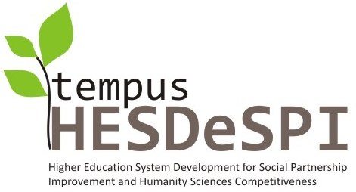
P R O T O C O L 11
Of Advisory Board establishment meeting

Date: | 25 June, 2011
Participated: | - participants (the list of participants is attached), including  - TEMPUS national office head Lana Karlova,  - Education and Science Minister Advisor Nerses Gevorgyan,  - Culture and Art sector – 9 participants,  - Press sector – 3 participants,  - Tourism sector – 1 expert,  - Architecture sector – 2 experts,  - Yerevan State Academy of Fine Art – 7 participants,  - YSUAC – 8 participants,  - Students – 3 participants.
Agenda: | - Introduction by YSUAC Administration representative (Vardkes Yedoyan).  - Brief self-introduction of invited participants.  - Project goal, objectives, expected outcomes. Advisory Board establishment purpose and activity objectives (Varazdat Hovhannisyan).  - Presentation on study tour visits and activity implemented by participants involved in the project (Irina Vanyan, Lilia Khachatryan, Armen Hovhannisyan, Taguhi Hovhannesyan, Lilit Hovumyan, Meri Patvakanyan and other).  - Speech of invited participants, discussions, questions and answers.  - Coffee Break.  - Advisory Board establishment decision making.
Considered: | - YSUAC vice-rector Vardkes Yedoyan presented in general the role of project YSUAC team members during the project implementation and stressed the achievements provided by team after one and half year of the project. V.Yedoyan suggested brief self-introduction.  - Self-introduction of participants.  - Project Coordinator V.Hovhannisyan presented the work implemented within the project during one and half year in accordance with schedule of approved work plan. He indicated that project team work planned by work plan is done in time and in accordance with planned volume. It was presented a necessity of Advisory Board establishment within the framework of the project. V.Hovhannisyan suggested the goal and objectives of Advisory Board.  - I.Vanyan presented the work implemented by project academic staff during one and half year, including results and lessons learned of study tour to Bologna University (Italy) on May 1-14, training courses development, training modules and appropriate training materials elaboration progress.  - Invited participants presented their opinions on Advisory Board establishment necessity. Particularly Design, computer design and information technology Dean Levon Toqmajyan presented the outcomes expected by the University from the newly created Advisory Board. TEMPUS national office head Lana Karlova, Yerevan State Academy of Fine Art vice-rector Svetlana Gevorgyan, Architectural Doctor David Tertmenjyan, YSUAC vice-rector Vardkes Yedoyan expressed their positive opinions on Advisory Board establishment necessity. The participants discussed suggestions around Advisory Board structural and organizational issues.
Questions asked: | Yu.Safaryan, D.Tertmenjyan, R.Minasyan.
Speeches: | Lana Karlova, Yu.Safaryan, Nerses Gevorgyan, Svetlana Gevorgyan, Sargis Tovmasyan.
Decision: | - Applaud the Advisory Board establishment initiative.  - Elect the Advisory Board staff (staff members list is attached).  - Elaborate of Advisory board working order.  - Call the Advisory Board kick-off meeting when the teaching modules drafts will be ready to be discussed.

Protocol maker: I.Gh.Vanyan
LIST OF PARTICIPANTS

## | Surname, Name | Institution | Position | Phone | Signature
1 | Khachatryan Lusine | “Aravot” newspaper | journalist | 093 14-09-84
2 | Hovhannisyan Ashkhen | YSUAC | student | 091 33-70-58
3 | Aharonyan Maria | YSUAC | student | 093 10-14-21
4 | Karapetyan Merujhan | AUA, digital library | Director on scientific issues | 51-27-67
5 | Khachatryan Grigor | "Mkhitar Sebastatsi" educational center | Study program manager | 093 61-80-78
6 | Avetisyan Nune | Modern Art Museum | Director | 53-96-37
7 | Grigoryan Grigor | Yerevan State Academy of Fine Arts | Lecturer, head of department | 077 44-14-24
8 | Mkrtchyan Mane | Art Center named by Gafestchyan | Coordinator of study programms | 091 31-96-15
9 | Bachachyan Armine | Art Center named by Gafestchyan | Assistant to head of exhibited funds department | 094 64-72-79
10 | Lusine Paravyan | Pan Armenian.Net | journalist | 094 81-91-98
11 | Ayrumyan Zara | Modern Art Museum | Deputy Director | 091 22-39-10
12 | Tajiryan Hovhannes | Yerevan State Academy of Fine Art | Lecturer | 091 46-00-91
13 | Hovumyan Lilit | YSUAC | Lecturer | 055 52-10-49
14 | Madoyan Zaruhi | YSUAC | Deputy of Dean | 091 50-02-53
15 | Stepanyan Naira | Yerevan State Academy of Fine Arts | International communications department | 093 46-29-47
16 | Azatyan Vardan | Yerevan State Academy of Fine Arts | Docent | 077 56-02-36
17 | Arevshatyan Ruben | Armenian Open University | coordinator | 093 87-56-99
18 | Karoyan Nazaret | AICA-Hayastan | Chief | 091 36-29-15
19 | Tovmasyan Sargis | YSUAC | Deputy of Dean, Faculty of Architecture | 091 42-75-19
20 | Hovhannisyan Armen | Yerevan State Academy of Fine Art | Lecturer | 093 10-11-10
21 | Vanyan Irina | YSUAC | Docent | 093 56-28-98
22 | Patvakanyan Mary | Yerevan State Academy of Fine Arts | International Communications Department Head | 091 50-74-61
23 | Minasyan Robert | Armenian Institut of Tourism | Rector | 091 22-66-20
24 | Baghdasaryan Ashot | YSUAC | Chair Head | 091 50-91-15
25 | Toqmajyan Levon | YSUAC | Dean | 093 92-40-40
26 | Yedoyan Vardkes | YSUAC | Vice-rector | 093 98-40-40
27 | Safaryan Yuri | YSUAC | Vice-rector | 093 71-40-40
28 | Tertmenjyan David | YSUAC/ Yerevan State Academy of Fine Arts | Doctor, Professor of Architect | 091 20-86-19
29 | Gevorgyan Svetlana | Yerevan State Academy of Fine Arts | Vice-rector | 094 26-80-93
30 | Karlova Lana | TEMPUS | Coordinator | 091 21-62-58
31 | Gevorgyan Nerses | RoA Ministry of Education and Science | Minister Advisor | 093 83-80-44
32 | Khachatryan Lilia | YSUAC | Lecturer | 093 69-11-46
33 | Stepanyan Sargis | YSUAC | Chair Head | 094 91-40-40
34 | Harutyunyan Siranuysh | Zhamanak I am  www.1in.am | journalist | 099 77-64-42
35 | Hovhannisyan Varazdat | YSUAC | Project coordinator | 093 07-13-53

Georgia
Annex 2 Georgia
  - Evaluation of the Study Programmes and their Responsiveness to the Requirement of the Higher Education Programme Tempus - Project HESDESPI

- Quality of the study programmes concept in related study courses (Humanity sciences, Culture administration); presence of elaborated 5 study modules and representation of necessary topics and skills in them.

- Syllabi for 5 study courses have been developed ("Intercultural Communications", "Human resources Management", "Use of New Information Technologies", "Project Management", "Culture Management"), which will be tested at the Master's program "Intercultural Communications" at Sokhumi State University. Each course consists of 5-6 ECTS.
- Currently, two training courses are being tested - "Culture Management" and "Intercultural Communications". The remaining three courses will be tested in the second semester. The three primary types of the last three courses have already been taught at other undergraduate programmes, but we made some alterations and customized them in accordance with the objectives of this particular Master's programme. The syllabi for the courses have been developed using new, modern scientific literature and include the themes and subjects that are important for the students in order to acquire deep knowledge of their specific area. Shota Rustaveli State University is testing the following study courses: "Use of New Information Technologies (at all bachelor programmes) and "Human Resources Management" at the Faculty of Humanities. Batumi Art University already has an undergraduate programme "Culture Management", which has been implemented successfully.

- Presence of training materials for elaborated study courses (quality and languages available) and methodology of use of training methods, case studies and workshop examples
Developed study courses are based on modern Georgian, Russian and English teaching materials. Lectures are delivered in Georgian and Russian languages. Training methods are paid big attention in order to make the learning process more successful. Different methods of teaching ("Project-Based Learning" (PBL), "Problem-Based Learning" (PBL), etc.) are used in the teaching process. During their work on project students conduct thematic researches in accordance with their project topics. The project is a part of the curriculum and is evaluated at the end of semester. Seminars are held in the traditional method (questions - answers).

- Methodological recommendations for developing qualification exam/paper content
Qualifications are awarded on the basis of bachelor's and master's thesis. The representatives of labour market participate in the development of thesis theme, preparation of the thesis and thesis defense process.

- Process of approbation and testing of training modules
Testing and approbation of the study courses is started at the existing Master's programme "Intercultural communications". Currently two training courses are being tested - "Culture Management" and "Intercultural Communications", which will be completed at the end of the first semester. The remaining three study courses are planned to be tested in the second semester.
- Links between the current study programme and other courses of study in the study related organisational unit
New developed study programmes are directly linked to the study programmes at the Faculty of Economics and Business: the study courses ("Culture Management", "Project Management" and "Human Resources Management") were chosen in order to increase students' employment opportunities.

- The compliance of study programmes with needs of labour market and future skills of graduates, the co-operation with labour market is justified (concluded contracts, agreements, meeting protocols etc.)
The demands of the labour market were taken into consideration while developing new study programmes. The current situation and problems of the cultural institutions have been reviewed. Also we got familiarized with their demands with respect to human resources. The requirements of cultural institutions have been taken into consideration in the selection and development of 5 study courses. With the purpose of future co-operation agreements were concluded with the Georgian Employers Association, Sokhumi State Dramatic Theatre, NGO "Multinational Georgia for Strengthening Democratic Values", under which students will be able to undergo internship at these institutions and reveal acquired knowledge and skills.
Georgian Employers Association provides recommendations and information about the trainings conducted by the foreign specialists in Georgia, so students of Sokhumi State University can participate in them.

- The compliance of study programmes structure and content with legal regulations in partner country
The structure and content of the study programme fully complies with state legal regulations.
- Quality of implementation of study programs- availability of human and technical resources
Study courses were elaborated by the competent academic staff of Sokhumi State University, who has extensive experience in the teaching of the appropriate courses.
Professional standards are not yet developed in the field of humanities. They will be developed in the nearest future.
- Use of state-of-the art equipment for implementing of educational programmes (e.g. computers, multimedia techniques, software)
Technical resources are profoundly used in the process of teaching (information technology, electronic resources sharing, etc.)

- Existence of developed professional standard for each qualification
Ministry of Education and Science of Georgia developed professional standards for professional education sphere where minimum credit value, mandatory knowledge, skills and values, areas of employment and additional requirements based on specifications of the profession are defined.
In the sphere of higher education, Sector Benchmarks is one of the mechanisms of quality assurance of higher educational programmes. Sector Benchmark is a document, which defines competences of educational programmes with regard to specific directions or field/specialization considering appropriate levels of education. The document is based on the National Qualifications Framework and European Qualifications Framework. It supports student mobility and development of joint educational programmes. Sector Benchmarks are developed in three directions - Law, Medicine and Education.
This document defines minimum competences that a holder of a corresponding qualification (bachelor, master, PhD) is expected to possess.
Sector Benchmarks have not been developed in other directions (neither in Intercultural Communications).
The qualification, objectives, fields of employment, credit value (ECTS), learning outcomes, teachings methods and methods required for achieving learning outcomes in the Master’s programme in “Intercultural Communications” have been developed and defined in accordance with the National Qualifications Framework. Master’s programme in “Intercultural Communications” was developed by Sokhumi State University and modernized in the framework of Tempus programme.

- Conformity of professional qualification for involvement in European Qualification Framework, development of documentation regarding ECTS and EQF
Sokhumi State University is a member of Bologna Process since 2005, which means that all the study programmes are assessed in ECTS. The documentations for the involvement in European Qualifications Framework (EQF) are being developed.

- Level of development of methodological recommendations regarding improvement of higher education offer, content and educational and management processes
Learning outcomes are defined in accordance with the national qualifications framework,namely:
Knowledge and understanding – after ending the programme graduates will have profound and systematic knowledge of such issues as intercultural relations, Turkish language, Turkish culture and history, interaction of business and intercultural management, social psychology as an important component of intercultural dialogue. This knowledge enables students to develop new and original ideas and find different solutions for the problems.
Applying knowledge/ practical skills – graduates are able to identify, analyze and solve complex problems using new, original ways under direct supervision as well as independently; comment on the research texts in accordance with the latest achievements; have the ability to use study materials through the usage of modern information technologies and interdisciplinary methods.
Making judgments - graduates have an ability to make conclusions based on the complex and incomplete information (including the most recent studies); are able to make synthesis of the information; possess planning and organization skills, decision-making and problem-solving skills.
Communication skills – graduates possess skills required for the usage of modern information technologies and technical equipment; management skills; are able to make conclusions and arguments as well as communicate in native and foreign languages (English, Turkish, Russian) in academic and professional circles; have developed social skills which are related to interpersonal relations, teamwork, expression of social and ethical responsibilities.
Learning skills – graduates are able to conduct independent studies, understand the peculiarities of the learning process; possess systematic skills (learning skills, skills required for adapting to new situations, independent and teamwork skills and management skills); possess strategic planning skills.
Values ​​– graduates are familiarized with the principles of tolerance and ethnocultural ethics, respect the culture of the communicant and at the same time realize the originality of their own values; are able to modify their behavior in accordance with the peculiarities of the intercultural relations; are able to identify and correct the causes of the cultural gaps; able to choose communication strategy and apply the rules of etiquette with the representatives of foreign cultures; are able to evaluate the attitudes towards the values and contribute to the development of the new values.
This program is designed to achieve the learning outcomes and the minimum competencies that must possess an appropriate master's degree holders, will be offered for the Ministry of Education and Science as a Working Draft of these qualifications, relevant characteristics of the formation process.
Learning outcomes and minimal competencies of Master Degree holder will be submitted to the Ministry of Education and Science of Georgia as a draft version for the development of the sector benchmarks for the given qualification.

- Publications in mass media and informative articles regarding the project and its outcomes
All project-related activities and project outcomes are published on the website and the newspaper of Sokhumi State University. The conferences held in the frames of the project were covered by media.
Answers of questions from ISMI from Georgia.
I’m sending you the answers for the recommendations provided by EACEA.
- The dialogue with the social partners should be effectively intensified in order to clarify curriculum content related issues and prospective of employment of future graduates.
An agreement of cooperation has been signed between Sokhumi State University and Georgian Employers Association. The agreement covers such issues as students’ internship and assistance in future employment at local organizations and institutions. Georgian Employers Association will provide recommendations and information on labour market demands.
- More and concrete attention should be I paid to advertising the project in local, regional and national media, as well as to dissemination of project results as it will help build the network and ‘culture’ cluster for the future.
All the activities connected to the project are published in the newspaper of Sokhumi State University and on the official website of TEMPUS - IV HESDESPI project (Georgia) www.sou.edu.ge/tempus. The conference held at Shota Rusatveli State University and Batumi Art Teaching University (27 May – 2 June, 2011) were covered by regional TV media.
- The cooperation with the national authorities (MoES, Ministry of Labour, regional and local employment agencies) should be effectively strengthened as they represent a good source of information and asset to increase university competitiveness.
The Deputy Head at the Ministry of Culture and Sport (Adjara) Ms. Aida Abuseridze took part in the conference held at Shota Rustaveli State University and expressed her support in the project implementation process. The meeting with the Minister of Culture and Sport (Adjara) Mr. Gia Abuladze was held in June 2011. The Head of Higher Education Development Division at MoES of Georgia Mr. Nugzar Chitaia participated in the monitoring visit held by project expert Mr. Hans Skoglund (October, 2011). The heads of departments at the Ministry of Culture (Georgia) provide assistance in the implementation of the project. The meeting with the partners from Bologna University has already been arranged at MoES of Georgia (November, 2011).
- As role of the MoES in this project is significant, and the approval of education standards to be developed depends on them, it is recommended to invite ministry officials to all events that are organised within the project in order to reinforce their participation in the project.
The representatives of MoES of Georgia actively participate in every meeting and activity held in the framework of HESDESPI project.
- A strategy for sustainable relationships with employers should be developed. As the dialogue between the universities and them has yet been established, clusters and networks could now be developed, e.g. between university professors and museums, tourist SMEs and university career centres, so that links between the Higher Education sector and society are largely explored: for instance for organisation of placement and internships for students, their employment when the programme is completed etc.
In the framework of the project Sokhumi State University and theaters, museums and touristic agencies have signed the agreements of cooperation. In the frames of the agreement the students of Master programme “Intercultural Communications” will undertake internship; the lectures in “Culture Management” will be delivered at the theatres; students will get familiarized with the administration system and management processes at these organizations, etc.
- We took note of the comments with regard to the modules and that two out of five modules will be common for all study programmes. We still perceive the ‘synergy effect’ of this multinational project as rather low because developed teaching modules and disciplines are only partially compatible between the participating countries. Thus, we still encourage the project management team considering further possibilities to strengthen the aspect of synergies and to consolidate results.
Five study programmes have been developed at Sokhumi State University: Culture Management, Intercultural Communications, Project Management, Use of Modern Information Technologies, Human Resources. Two of these study programmes are common for all the partner universities: Human Resources and Culture Management. Each study programme is made up of 5-6 ECTS. Two study programmes are being already tested during the first term at the Master Programme “Intercultural Communications”. Other three study programmes will be tested in the second term (February – June, 2012) at the Master Programme “Intercultural Communications”.
- Finally, we recommended that the project website could be further elaborated and used as an instrument to strengthen the cooperation with the project social partners and stakeholders in the partner countries in order to facilitate the planned reforms. The planned Advisory boards for all participating partner countries could be illustrated and disseminated through the website tool.
The website of HESDESPI project www.sou.edu.ge/tempus (Georgia) covers all the activities carried out in the framework of the project.
Annex 3 Moldova
Quality of the study programmes concept in related study courses (Humanity sciences, Culture administration); presence of elaborated 5 study modules and representation of necessary topics and skills in them. | The groups who were developed the curricula and syllabi were created under the principle a professional and research.  Cahul  1 Course: “Theoretical basis of educational management”  2 Course: “Human resources management in educational institutions”  3 Course: “New technologies applied in education”  4 Course: “Educational project management”  5 Course: “Quality management in education”  The module “Management of Educational Institutions” was introduced in Master programmes at the speciality: “Linguistics, Literature and Deontologics” and “History: southern-east European Studies”. It is operational from 2011-2012 study years.  According the Senate Decision of Cahul State University from June 22, 2011: “Approval of amendments which were made in Study plans of Cycle II (Master), at the programmes: “History: southern-east European Studies” (professionalization) and “Linguistics, Literature and Deontologics” (professionalization).  Balti  Level II Master speciality Romanian Language and Literature: Temporal and spacial varities (Romainan/Russian)  Module Culture Management 10 credits  Theoretical Basis of Management  Project Management  Intercultural Communication  Linguistic Culture Studies  Management of culture forms  Level II Master speciality Modern Didactics of Philological Disciplines (Romanian) Level II Master  Module The of Educational Institutions 10 credits  Theoretic Basis of Educational Management  The Management of Human Resources in Educational Organizations  Communication Management  Epistemology and Methodology of Linguistic Research  The Theory of Language in Pre-university Education
How many courses? How many students? | Cahul One module includes 5 courses: Semester 1 - 12 students and semester 2 - 15 students  Balti Sem 1 17 students s 2 26 students
Presence of training materials for elaborated study courses (quality and languages available) and methodology of use of training methods, case studies and workshop examples | Cahul 2 own produced and written books that will be printed as real books.  Courses materials for the module were developed.  Concerned courses were discussed at the Scientific-methodological Commission and were recommended for publication. The structure of the guide “Management of Educational Institutions” is:  - The Chapter name  - Content of the units.  - Objectives.  - The Key concepts.  - Reflection problems and application.  - Bibliography  It will be approximatively 812 pages A5.  Balti books to each course 70 pages each.
Methodological recommendations for developing qualification exam/paper content | C Has been approved by the Senate  B Will do it mext year.
Process of approbation and testing of training modules | Cahul has started:  The module “Management of Educational Institutions” was introduced in Master programmes at the speciality: “Linguistics, Literature and Deontologics” and “History: southern-east European Studies”. It is operational from 2011-2012 study years.  According the Senate Decision of Cahul State University from June 22, 2011: “Approval of amendments which were made in Study plans of Cycle II (Master), at the programmes: “History: southern-east European Studies” (professionalization) and “Linguistics, Literature and Deontologics” (professionalization).  B Have been discussed and been changed
Links between the current study programme and other courses of study in the study related organisational unit | Cahul:  The course “Management of Educational Institutions” directly linked with the Psych-Pedagogical Module, which is realized at cycle I (License).  In a purpose of updating the legal framework on the organization of higher education, the Ministry of Education from Moldova has issued the order regarding to the framework plan for higher education no. 455 from June 3, 2011, which was implemented the framework plan for higher education. According to punct 2 of the order, educational institutions should elaborate and made compatible educational plans, in accordance with the requirements of the Framework Plan.  In this context, university didactic staff has initiated a comprehensive process of rethinking their curricula.  Balti (cred ca la fel)  Yes has been tested on Master Students
The compliance of study programmes with needs of labour market and future skills of graduates, the co-operation with labour market is justified (concluded contracts, agreements, meeting protocols etc.) | Yes everything of this is done. Contracts is clear.  Cahul:  The demands of the labour market were taken into consideration while developing new study programmes. The current situation and problems of the educational institutions have been reviewed. Also we got familiarized with their demands with respect to human resources. The requirements of educational institutions have been taken into consideration in the selection and development of 5 study courses. With the purpose of future co-operation agreements were concluded with:  - General Educational Department of Cahul district  - The District Archive, Cahul city.  - The Museum of Cahul city.  - The Association of Democratic Cooperation and Communication “Dialog”, Cahul city.  - Gymnasium “A, Mateevici”, Manta village  - Theoretical Lyceum “M. Eminescu”, Cahul city  - Theoretical Lyceum “Ion Creanga”, Cahul city  - Theoretical Lyceum “P. Rumeanthev”, Cahul city  - Theoretical Lyceum “S. Rahmaninov”, Cahul city  - Theoretical Lyceum “D. Cantemir”, Cahul city  - Cahul Industrial-Pedagogical College.
The compliance of study programmes structure and content with legal regulations in partner country | Cahul State University and Balti State University are members of Bologna Process since 2005, which means that all the study programmes are assessed in ECTS. The documentations for the involvement in European Qualifications Framework (EQF) are being developed.  The higher education, except for medical and pharmaceutical education, is carried out in two stages:  - Cycle I - bachelor studies;  - Cycle II - master studies.  The didactic activity in higher education is divided into three categories: full-time, part-time and distance education.  The practice stages are mandatory in higher education. The duration of the part time and distance education is longer a year than the full time studies.  The bachelor studies generally last three to four years, and one academic year has 60 transferable credits.  The cycle I of higher education is ended with passing the licensing examination, which includes a profile task, a specialty exam and the defending of a project (thesis). These exams are conducted according to the general criteria established by the Ministry of Education.  Graduates who passed the two licensing examinations and defended a thesis are granted the title of licensed specialist in the studied domain, and are issued diploma of bachelor studies.  The diploma of bachelor studies certifies that its holder has acquired general knowledge and skills for further studies in the second cycle, as well as an initial training which enables to be employed.  The master studies last 1-2 years, and one academic year has to 60-120 transferable credits. The master studies are held for bachelor diploma holders, and provide full time studies, specialization in a certain field or extend and improve the scientific and pedagogical training. The holders of Bachelor degree in medicine or pharmacy are admitted to master studies as well.  The master studies are divided into two categories: professional and research. The postgraduate studies aim to develop students' research skills, and are a mandatory pre-stage for doctoral studies. These studies provide deepening students’ knowledge in specific content areas, thus being focused primarily on developing applicative skills.  The plan for admission to master studies on budget finance is approved by the Government, and provides admission to 50% of the total number of graduates with bachelor degree of that year. Admission to master studies is made through competition, and is based on criteria established by the Ministry of Education.  The master studies are completed with master thesis defending. Graduates who successfully defended the master thesis are issued Master diplomas. The master degree certifies that its holder has acquired general and specialized knowledge and skills, as well as specific cognitive abilities. The master’s degree confers the right to hold teaching positions in higher education institutions and to carry out scientific research or to participate in the competition for admission to PhD studies.  Starting with 2005, the graduates of higher education institutions are issued compulsory the Diploma Supplement.  It is uncertain the status of doctoral and post-doctoral studies because the Academy of Sciences of Moldova deals with this level of education.
Quality of implementation of study programmes- availability of human and technical resources | Cahul :  Study courses were elaborated by the competent academic staff of Cahul State University, who has extensive experience in the teaching of the appropriate courses. After testing it will be proposed to the Continuing Education Centre as a training program for managers of educational institutions. Technical resources are profoundly used in the process of teaching (information technology, electronic resources sharing, etc.)
Use of state-of-the art equipment for implementing of educational programmes (e.g. computers, multimedia techniques, software) | Cahul State University has the Psychological and Pedagogical Laboratory, 4 multimedia rooms, which offer the possibility to students and teaching staff to explore the new informational technology for implementing of educational programmes and to have access to the Internet.
Existence of developed professional standard for each qualification | Yes teachers has been educated during seminaras and education in Bologna, Braga and Riga.  The seminar concerning professional analyzing was organized, as a purpose to develop professional standards for teachers of history (28.09.2011).  Essential objectives of the seminar were:  - to determine the essential duties of the professor of history  - to determine related tasks to every activity.  - to determine necessary skills, knowledge, attitudes, resources.  Experienced teachers from Cahul district and city schools have participated at the seminar.  According accumulated information on this seminar as after others meetings was elaborated professional standard “professor of History”. Present, this standard is in a process of discussions.
Conformity of professional qualification for involvement in European Qualification Framework, development of documentation regarding ECTS and EQF | C and B has given suggestions to the board but they have not made any decissions, maybe because the unstable political situation. This has been going on since 2006. But they are still lobbying.
Level of development of methodological reccomendations regarding improvement of higher education offer, content and educational and management processes | Studies have been written and presented.
Publications in mass media and informative articles regarding the project and its outcomes | This has been done through the normal University channels, the website, seminars and press. They have also written a book.  Cahul:  All project-related activities and project outcomes are published on the website of Cahul State University and the local newspapers.  Mr. S. Cornea has published the article “Considerations for social actor’s involvement in the process of specialist’s preparation in the Republic of Latvia" in Cahul State University Scientific Annals (Vol. VI. – Cahul, 2010, p.192-196)  In a regional newspaper “Cahul Expres” no.20, 2010, Mrs. E. Mandaji has published a material “TEMPUS project is implemented in Cahul".  In institutional newspaper “Universitas” no.7, 2010, was published the material about “Higher Education System and Labour Market”.  In institutional newspaper “Universitas”, no.7 p.2, 2010, was published the material signed by S. Cornea “Considerations for social actor’s involvement in the process of specialist’s preparation in the Republic of Latvia".  Mrs. L. Chiciuc has participated with a report "On the issue of employment of young graduates of History specialty" at the International Scientific and Practical Conference "Integration of Higher Education Professionals into the Labour Market: National and International Aspects" on 21-22 of October, 2011, which were held in Balti (Republic of Moldova).  Mr. S. Cornea has participated with a report “The importance of occupational analysis for the professional standards development of didactic staff" at the International Scientific and Practical Conference "Integration of Higher Education Professionals into the Labour Market: National and International Aspects" on 21-22 of October, 2011, which were held in Balti (Republic of Moldova).

Ukrainian Team

Higher Education System Development for Social Partnership Improvement and Humanity Sciences Competitiveness
Annex 4 Ukraine

Tempus Project

- Quality of the study programmes concept in related study courses (Humanity sciences); presence of elaborated 5 study modules (per Ukrainian university (PARTNER)) and representation of necessary topics and skills in them.
- Presence of training materials for elaborated study courses (quality and languages available) and methodology of use of training methods, case studies and workshop examples
- The full list of modules please find in the attached file: “Modules HESDeSPI_Ukraine.pps”

A draft version of the modules was prepared during the reported period; modules were presented and discussed at a session of the scientific and methodical commission of the PARTNER`s Department and at a session of Academic Council of PARTNER`s Faculty. On the whole, the teaching and methodical activities in the Project over the reported period were mostly carried out along the following lines:
1) analysis of the potential labour market for graduates trained for the partner specialty (survey of employers in the area of culture; Round table discussion "Modernization of the Educational Process as a Means to Meet the Demands of the Labour Market in the Field of Cultural Management" );
2) compilation, based on relevant analysis, of the list of requirements to be satisfied by future specialists in culture management;
3) development of professional standard with employers (based on the European method, the moderator – Sniedze Joma, Latvia); the title of specialty is “Management of the Socio-cultural Projects and Programs”;
4) preparation, agreement, and adjustment of the teaching and methodical support to the educational process (content of modules, model programs of academic disciplines, teaching materials models).
- Methodological recommendations for developing qualification exam/paper content
According to the requirements of Ukrainian Ministry of Education the studying and methodic kit of documents for every discipline includes qualification exam. This means that every programme includes the detailed description of the forms of control, the content of qualification exam, criterion of examination.
- Process of approbation and testing of training modules
Since September 2011 PARTNER`s University the approbation of studying modules has started. Ten new disciplines would be approbated this year. Since September, 1 one can find 4 new disciplines and 2 disciplines that were upgraded taking into account the chosen by the employers professional standard. Since February 2012 (2nd semester) 6 new disciplines would be deployed.
The whole process of working out new modules and programmes has been discussed during the scientific methodological seminars so that it is possible to guarantee high quality of study materials. The results of courses’ approbation would also be discussed at scientific methodological seminar.
- Links between the current study programme and other courses of study in the study related organisational unit

The studying plans were revamp and re-approved in accordance with the established procedure and in compliance of TEMPUS project programme.
- The compliance of study programmes with needs of labour market and future skills of graduates, the co-operation with labour market is justified (concluded contracts, agreements, meeting protocols etc.)
July-August 2010 – survey of employers in the area of culture in the following topics: the quality of education; matching the level of training to labour market needs, training young professionals in the field of cultural management in accordance with the requirements of employers. Within the research the letters and the questionnaires were sent to 46 enterprises, associations and organizations of culture and tourism of Crimea, , we have received 24 replies from the heads of these institutions that supported the expediency of the students’ education on the given specialty. Among the basic specialties described by the employers needed for their organizations’ activities it is possible to underline the following: managers of museum activity, managers of tourist activity, methodologists-organizers, art critics, teachers-psychologists, research scientists, marketing experts, experts in management of collections, etc.

8/10/2010 - Round table discussion "Modernization of the educational process as a means to meet the demands of the labour market in the field of cultural management". The round table was attended by: 1) The project team; 2) The representatives from the Ministries of the Autonomous Republic of Crimea: the Deputy Minister of Education and Science ARC Ablyatipov A., the Deputy Minister of Culture and Arts ARC Zaatov I.A., the Head of human resources and alternative service of the Ministry of Labour and Social Policy ARC Bitter I.V., the Deputy Head of the organizational facility of the employment of the Crimean Employment Center Boris I.V. etc. 3) Employers: Director of the Museum of History Simferopol Vdovichenko I.I., Director of emergency "travel company" ONYX Teplukhin A.V., Director of CRU "Crimean museum of art" Gemedzhi N.A., the Head of Business Association of Regional Development Beresneva M. A. etc.
In the course of the Round Table there was actively discussing of the issues related to the development and implementation of mechanisms of interaction between employers and higher education systems, assessment of the quality of education; match the level of training to labour market needs. Participants in the Round Table stressed the particular importance of increasing social responsibility of all participants in the educational process, an active search for new forms of educational work in order to effectively motivate the social partners to work together; changes in approaches to the development of educational standards, including the ones in the field of cultural management; construction of an effective mechanism of cooperation of education and employers to improve the quality of education: the active participation of employers, not only in the process of creating a standard (necessity to create a methodology for making the standard), but also in the evaluation of curricula of training (through the procedure of licensing and accreditation) and the direct participation of employers in assessing the quality of education (through the qualifying examinations).
A number of contracts has been signed concerning partnership between PARTNER`s department and Employers’ association.
- The compliance of study programmes structure and content with legal regulations in partner country
Educational subjects that are components of modules are worked out according to the Law on High School and Ukrainian Ministry of Education and Science, Youth and Sport specification documents. For all the disciplines of the module the whole educational kit of documents has been worked out according to the requirements of the Ministry.
The studying and methodic kit of documents includes study programme, training programme, plan of seminars and individual students’ work, criterion and form of examination, the list of references, and the content of examination.
- Quality of implementation of study programmes- availability of human and technical resources
PARTNER Universities generally has all the necessary resources to guarantee high quality teaching of new modules. University possesses good equipment support. Also within TEMPUS project the new technique (computers, multimedia equipment) has been obtained to provide high quality of teaching new courses.
The staff corresponds the courses taught. To provide the high quality teaching of new modules the Culturology department involves specialists from other university faculties and departments.
- Conformity of professional qualification for involvement in European Qualification Framework, development of documentation regarding ECTS and EQF
As soon as Ukraine aspires to be included to European Educational field and to provide students’ mobility all the study subjects that form the specialists’ training programme are worked out taking into account ECTS.
The credits rate all the components of year study programme: modules, study subjects, practice, preparing diplomas, etc. Credits are also a mean of quantitative rating of studying achievements. Student gets credits only for those components of programme that he had done in full, passed the exam or other form of examination according to the studying plan.
The success of students is rated in national scale of grades, but it became a rule to duplicate national scale of grades in students’ report books and in other documents in ECTS. It is reflected in the programme of each course.
As of the date of making an application for TEMPUS programme Ukraine had no National Qualification Framework even in project. So performing TEMPUS project working group studied the European partners’ experience (in particular Latvia, we met the developer group of Latvian no National Qualification Framework). In 2010 the Ministry of Education and Science of Ukraine initiated the creation of working group for developing no National Qualification Framework. In May, 2011 the result of working group’s activity has been presented on the site of the Institute of Innovative Technologies and Content of Education (which is a department of Ukrainian Ministry of Education and Science). We studied the project of National Qualification Framework and compared it with European and Latvian one. The comparative table is presented in Ukrainian and in English. The result of the comparison could be characterized in the following way: Ukrainian no National Qualification Framework is highly approximated to European one (that reflects the position of Ukrainian Ministry of Education and Science), but the very description and the very descriptors are more complicated then in European Framework.
- Level of development of methodological reccomendations regarding improvement of higher education offer, content and educational and management processes
The main result of the project should become a methodic recommendation on improving the system of higher education. The working group is working on it since the very beginning of the project. So the investigation held (draft variant) in its summary is a part of future methodic recommendations. The results of employers’ interviewing, round table discussion summary would be included to the final methodic recommendations too. The methods of developing national standards in cooperation with the employers would be an important practical part of methodic recommendations. During the project its coordinator – Latvia- held two-week courses for moderators (one for every university of the consortium).
The development of one more important part of methodic recommendations is scheduled for the nearest future. It concerns part and functions of the professional standard in the Ukrainian education field. To develop this part we get in contact with Institute of Innovative Technologies and Content of Education. Besides this we prepared a report for the conference “Problems and Perspectives of an Employment of High Education Institutions Graduates” (November, 10, Donetsk) to discuss the possible forms of using professional standards with spokespersons of other educational institutions and ministries of Ukraine. The working group of our project would present the report “European and Ukrainian Experience in Working Out professional standards with the employers’ participation. Problems and Perspectives”. We would like to share our experience in working out standard in cooperation with employers and to know the opinion concerning the effectiveness of implementation this standards from education representatives, employers, employment centers.
Publications in mass media and informative articles regarding the project and its outcomes
Publications in mass media and information articles concerning the project and its results.
For the dissemination purposes, Taurida National V.I. Vernadsky University presented the TEMPUS Project 159338-TEMPUS-1-2009-LV-TEMPUS-SMHES «Higher Education System Development for Social Partnership Improvement and Humanity Sciences Competitiveness» at the following conferences and forums:
1) Report to the Council on internationalization (international activity support) of TNU about TEMPUS project. –I. Andriushchenko, 13.03.2010;
2) The international scientific conference "Culture of People of Prichernomorya from the most Ancient Times to our Days" and jointly with the Crimean scientific center of NAN of Ukraine (April 2010, November 2010, April 2011 – I. Andriushchenko, Z. Hairedinova, Y. Katunin); abstracts and papers published in the Crimean scientific magazine "Culture of People of Prichernomorya" (ISSN 1562-0808), 201; web-site of magazine: http://www.nbuv.gov.ua/Articles/KultNar/index.html;
3) I International Scientific and Research Conference «Problems and Perspectives of Cultural Tourism Development in Ukraine and in the World» (Ukraine, Crimea, Sevastopol - May, 21-22 2010); Section 1. Present-day problems of higher education in the field of cultural tourism and culture management; I. Andriushchenko «Higher Education in the Humanities and the Labor Market: Opportunities and Prospects for the Dialogue»; web-site of event: http://umi.com.ua/stryktyra-pymi/fakyltet-menedjmenta-otelno-restorannogo-i-kryiznogo-biznesa/naychnaia-rabota-fakylteta.html;
4) Round table discussion "Modernization of the Educational Process as a Means to Meet the Demands of the Labor Market in the Field of Cultural Management" (8.10.2010) - meeting was held with representatives of the Ministries of the Autonomous Republic of Crimea and Employers;
5) “The Information Fair” on work of international projects on the territory of the autonomy in the Supreme Council of the Autonomous Republic of Crimea (April 19/2011)
web-site of event: http://www.rada.crimea.ua/en/news/15_06_11_9);
6)VI I International Scientific and Research Conference “Problems and prospects for employment of graduates of Higher educational institutions” (Ukraine, Donetsk, 10.11.2011),
I. Andriushchenko “European and Ukrainian experience in the development of professional standards with employers: problems and prospects”;

6) local web-site: http://www.philotnu.org/news/250-news3.html

